**LABORATORY PROGRAM – 3**

Create a class Book which contains four members: name, author, price, num_pages. Include a constructor to set the values for the members. Include methods to set and get the details of the objects. Include a toString( ) method that could display the complete details of the book. Develop a Java program to create n book objects.

**OBSERVATION :**

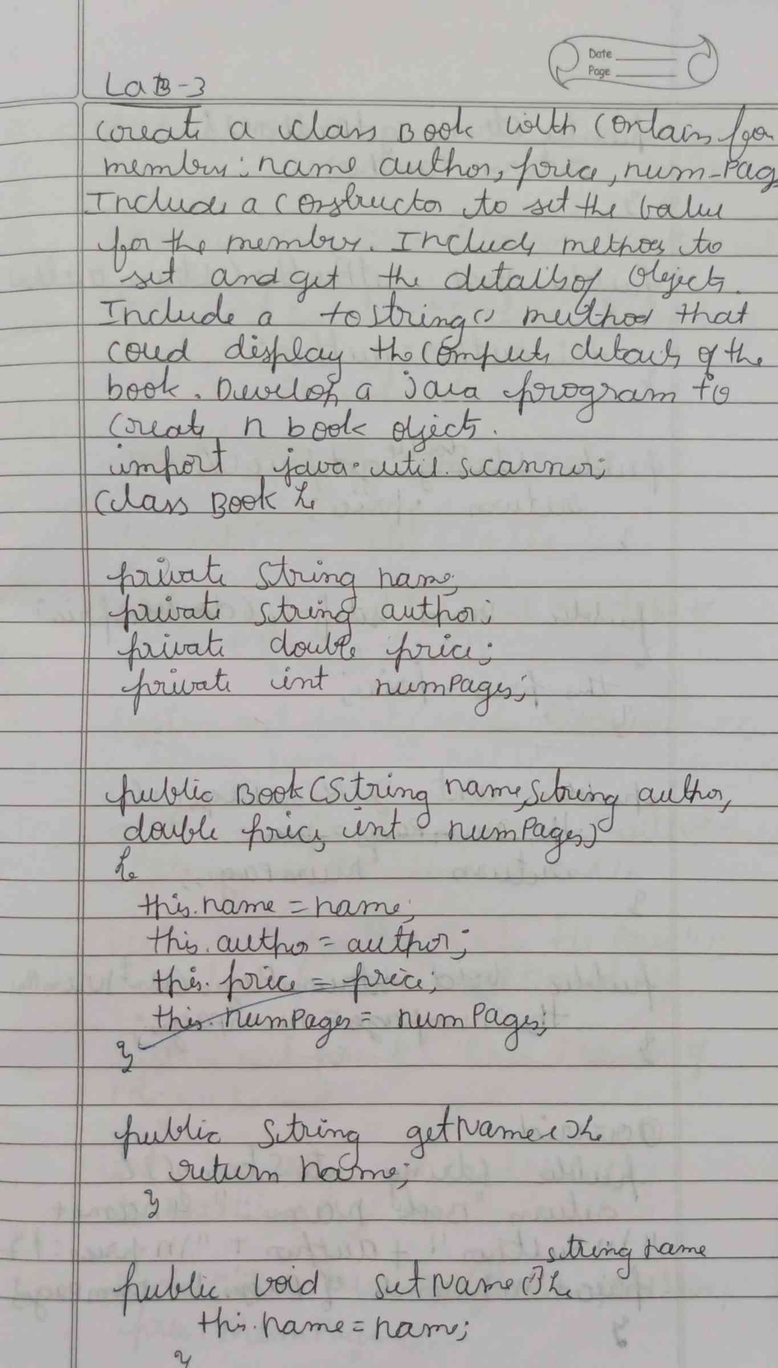

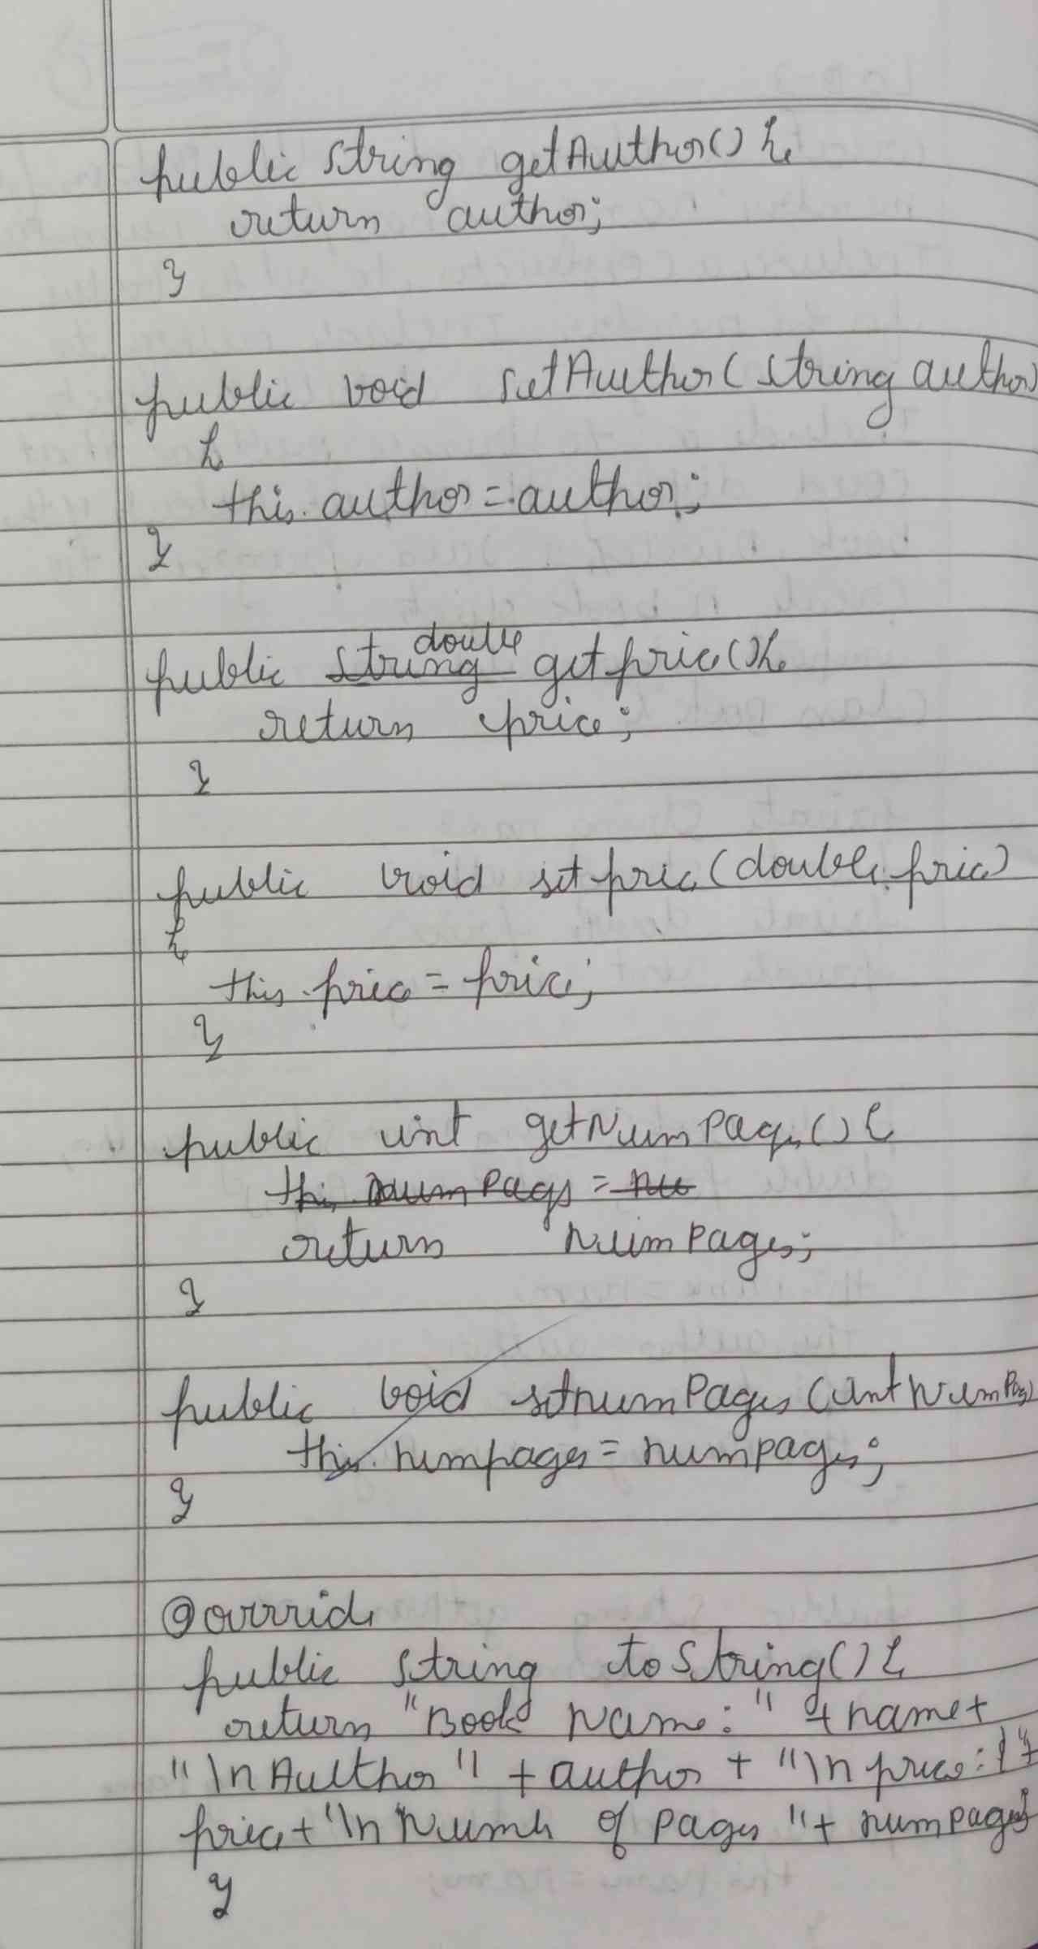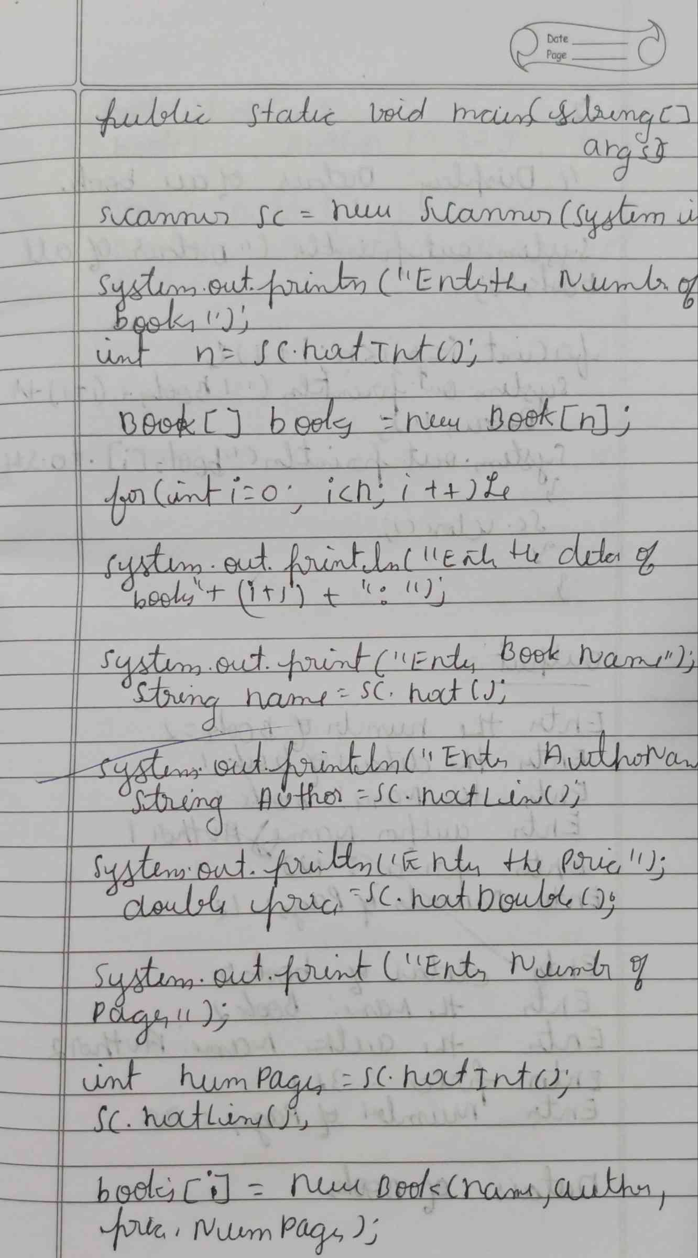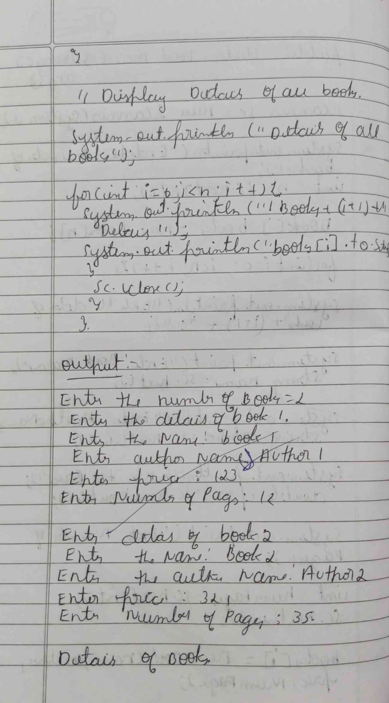

**CODE :**

**import java.util.Scanner;**

**class Book {**

**private String name;**

**private String author;**

**private double price;**

**private int numPages;**

**public Book(String name, String author, double price, int numPages) {**

**this.name = name;**

**this.author = author;**

**this.price = price;**

**this.numPages = numPages;}**

**public String getName() {**

**return name;}**

**public void setName(String name) {**

**this.name = name;  }**

**public String getAuthor() {**

**return author;}**

**public void setAuthor(String author) {**

**this.author = author;}**

**public double getPrice() {**

**return price;}**

**public void setPrice(double price) {**

**this.price = price;  }**

**public int getNumPages() {**

**return numPages;  }**

**public void setNumPages(int numPages) {**

**this.numPages = numPages;}**

**@Override**

**public String toString() {**

**return "Book Name: " + name + "\nAuthor: " + author + "\nPrice: " + price + "\nNumber of Pages: " + numPages;  }**

**public static void main(String[] args) {**

**Scanner sc = new Scanner(System.in);**

**System.out.print("Enter the number of books: ");**

**int n = sc.nextInt();**

**sc.nextLine();**

**Book[] books = new Book[n];**

**for (int i = 0; i < n; i++) {**

**System.out.println("Enter details for book " + (i + 1) + ":");**

**System.out.print("Enter Book Name: ");**

**String name = sc.nextLine();**

**System.out.print("Enter Author Name: ");**

**String author = sc.nextLine();**

**System.out.print("Enter Price: ");**

**double price = sc.nextDouble();**

**System.out.print("Enter Number of Pages: ");**

**int numPages = sc.nextInt();**

**sc.nextLine();**

**books[i] = new Book(name, author, price, numPages);**

**}**

**System.out.println("\nDetails of all books:");**

**for (int i = 0; i < n; i++) {**

**System.out.println("\nBook " + (i + 1) + " Details:");**

**System.out.println(books[i].toString());**

**}**

**sc.close();**

**}**

**}**

**OUTPUT :**

